**(BCA)**



**NALANDA OPEN UNIVERSITY**

biscomaun bhawan,gandhi maidan,patna ,bihar 800001

BACHELAR OF COMPUTER APPLICATION(BCA)

**PAPER-XIV(Project)**

**GUIDED BY: PREPARED BY:**

**AMIT KUMAR KOMAL KUMARI**

**EN-NO :190560062**



# SCHOOL OF COMPUTER SCIENCE AND INFORMATION TECHNOLOGY NALANDA OPEN UNIVERSITY, BISCOMAUN BHAWAN, PATNA – 800001

**PROFORMA OF BCA PROJECT PROPOSAL (Paper-XXIV)**

**(Project’s Title and Guide Details)**

**Enrolment No.………………………**

# E-mail: ………….………..…………

**Telephone No.………………………**

1. Name and Address of the student ………………………..………………………………….

……………………………………………………………

……………………………………………………………

2. Title of the Project .………..………………………………………………….

3. Name and Address of the Guide …..……………………………………………………

……………………………………………………………

1. Qualification of the Guide (Attach bio-data also)

………………………………………………………………

Ph.D/M.Phil. M.Tech. MCA Any other

Note: All the above mentioned Degrees must have been awarded in Computer Science/IT only

1. Industrial / Teaching experience of the Guide (in Years) ………………………………………………..

6. Software Used ………………………………………………………………

(**Note** : Use of Visual Basic and MS-Access as Front End and Back End respectively is forbidden. But, you are permitted to use Visual Basic with other Software. Also, you can use MS-Access with other software)

Signature of the Student Signature of the Guide

Date: ………………… Date: …………………

**Important: 1. Attach this Proforma along with Guide’s Bio-data and Project Synopsis in the Project Report.**

**2. Not more than one student is permitted to work on a project.**

**LIST OF BROAD AREAS OF APPLICATION AND RELATED TOOLS**

**FRONT END / GUI Tools :** Visual Basic, Power Builder, X-Windows (X/lib,

X/motif, X/Intrinsic), Oracle,VC++, Jbuilder

**RDBMS/BACK END :** Oracle, Ingres, Sybase, Progress, SQL Plus, MY SQL,

SQL Server, DB2

**LANGUAGES :** C, C++, Java, VC++, C#

**SCRIPTING LANGUAGES :** PERL, SHELL Scripts(Unix)

**RDBMS/BACK END :** Oracle, Ingres, Sybase, Progress, SQL Plus, Versant,

MY SQL, SQL Server, DB2

# MIDDLE WARE (COMPONENT) TECHNOLOGIES :

COM/DCOM, Active-X, EJB, Rational Rose, MSMQ, BEA, Message Q, MTS, CICS

**UNIX INTERNALS :** Device Drivers, Pipes, RPC, Threads, Sockets

**ARCHITECTURAL CONCEPTS :** CORBA, TUXEDO

**INTERNET TECHNOLOGIES :** DHTML, Java script, VB Script, Perl & CGI script,

HTML, Java, Active X, RMI, CORBA, SWING, JSP,

ASP, XML, EJB, Java Beans, Java Servlets, Visual Age for JAVA, UML, VRML, WML, iPlanet, ATG, BigTalk, CSS, XSL, Oracle ASP server, VB.Net, AWT, J2EE, LDAP, ColdFusion

**NETWORKING TECHNOLOGIES :** ATM, Frame Relay, TCP/IP, SNMP, GSM, VoIP, PPP,

IP-PSTN, SONET/SDH

**WIRELESS TECHNOLOGIES :** Blue Tooth, 3G, ISDN, EDGE

# REALTIME OPERATING SYSTEM/ EMBEDDED SKILLS :

QNX, LINUX, OSEK, DSP, VRTX, RTXC, Nucleus

**OPERATING SYSTEMS :** WINDOWS XP/Vista/7/8, UNIX, LINUX, IRIX, SUN

SOLARIS, HP/UX, PSOS, VxWorks, AS400, AIX

**APPLICATIONS :** Financial/ Manufacturing/ Multimedia/ Computer Graphics/ Instructional Design/ Database Management System/ Internet/ Intranet/ Computer Networking- Communication Software/E-Commerce/ ERP / MRP/ TCP/IP Internals/ Routing protocols/ Socket Programming/ Implementation of Switches & Routers

**CERTIFICATE OF ORIGINALITY**

This is to certify that the project report entitled

Submitted to **Nalanda Open University, Patna** in partial fulfilment of the requirement

for the award of the degree of **BACHELOR OF COMPUTER APPLICATIONS ( BCA) ,** is an original work carried out by Mr./ Ms.

Enrolment No.: under the guidance of Mr./ Ms.

The matter embodied in this project is a genuine work done by the student and has not been submitted whether to this University or to any other University / Institute for the fulfilment of the requirement of any course of study.

Signature of the Student Signature of the Guide

Name and Address Name, Designation and

of the Student : Address of the Guide

Enrolment No.:



**NALANDA OPEN UNIVERSITY**

# 3RD FLOOR, BISCOMAUN BHAWAN, PATNA – 800001

**School of Computer Science and Information Technology**

**P R O J E C T T R A I N E E L E T T E R**

Sir,

# Subject: Project Trainee

**Date:**

This is to certify that Mr./Ms. whose Enrolment

No. is a student of BCA Programme of Nalanda Open University and has to do a project in his/her final year. The project is compulsory for BCA programme. S/he has to do a project for 3 months in Industry/Research Laboratories under the supervision of a guide preferably from the same organisation. During his course, the student has gone through several theoretical papers such as Data Structures, Database Management System, C++, TCP/IP Programming, Intranet Administration, Java Programming, Computer Networks, S/W Engineering etc.

Looking forward for your positive response.

# Signature& Name of Registrar (Exam)

**with Date and Stamp**

***Note: This letter may also be signed by the coordinator of the subject concerned.***

**CURRICULUM VITAE**

AMIT KUMAR

CO- Mr. Abhay Kr. Pandey

Late Akhileswar Pandey mob : -

Opp. Patna College,

Ashok Rajpath. E-mail:

Patna-800004

**SNAPSHOT**

* Currently serving as a Software Developer in EON TECHNOLOGIES, Patna.
* Successfully handled projects on ERP, Payroll Management System Invoicing and Inventory
* Well versed with JAVA, JSP, SERVLET, CORE JAVA, SQL, Oracle 9i and XML.
* An analytical mind with the ability to think clearly and logically.
* Ability to work accurately and pay attention to details.
* A well organized and result oriented team player.
* Excellent spoken & written communication skills and problem solving skills.
* Sound knowledge about the latest developments in the field of Computers.
* Successfully handled the projects on Mini ERP System based on Java
* Technology.
* Hands on Experience of 2 years as a Software Engineer in the field of Various Technologies, Framework, Application & Web Server in Java.
* Proficient in Swing, JSP & Servlet, Struts, Spring, Hibernate, AJAX, Tomcat, Weblogic.

**Educational Qualification**

* MCA from G.I.E.T, Gunupur (B.P.U.T) in 2007 with 75.0%.
* BCA from Gaya College, Gaya (Magadh University) in 2004 with 68.0%.
* 12th in 2001 from B.I.E.C. with 72.1%.
* 10th in 1999 from B.S.E.B. with 69.9%.

**IT Exposure**

Operating System : Windows-2000,XP, Linux

Language : Java, J2ee, Struts 1.1/2.0, Spring, Hibernate, Swing.C

Internet Technology : SP, Servlet, HTML, JAVASCRIPT, Ajax

Application/web server : JBoss 4.0, Tomcat 5.5. Weblogic8.0/9.0.

Database : MS-SQL 2000-2005, Oracle9i(PLSQL).

IDE : My Eclipse ,Eclipse,Netbeans-5-0/6.1,

**Professional Experience**

Organization : EON Technologies ,patna (May-2008 to till data )

Website : http:/www.eontechnologies.co.in

Organization : Novita Soft Solutions,Bangalore(April 2007-April 2008)

Website : http:/www.novitasoftsolution.com

**Personal Details**

|  |  |
| --- | --- |
| Father’s Name |  |
| Data of Birth |  |
| Marital status |  |
| Language Known |  |
| Nationality |  |

**Acknowledgement**

I declare that all the information given above are true and based on my knowledge.

Place : -Patna (AMIT KUMAR)

Date : -

**Students Profile Management**

**A**

**Project Report**

***Submitted in partial fulfillment of the requirement for the award of***

***the degree of***

**Bachelor of Computer Applications**

**Submitted to**

**NALANDA OPEN UNIVERSITY**



|  |  |
| --- | --- |
| Submitted By | Under Guidance of |
| **KOMAL KUMARI** | **Amit kumar** |
| Enrolment No. **190560062** | Asst. Professor |
| Session-2019-2022 | Computer Science & |
| BCA-3TH Year | Information Technology |

** NALANDA OPEN UNIVERSITY**

**Department of Computer Science & Information Technology**

**Session 2019-22**

**Certificate**

This is to certify that the work embodies in this project entitled, **“College Event Management”,** being submitted by **KOMAL KUMARI (190560062)** in partial fulfillment of the requirement for the award of “**Bachelor of Computer Applications”** to NALANDA OPEN UNIVERSITY **University, Patna** during the academic year 2019-22 is a record of bonafide piece of work, carried out by him under our supervision and guidance in the **“Department of Computer Science & information Technology”, NALANDA OPEN UNIVERSITY.**

**Er. A N Panday**

Head of Department-IT

 **NALANDA OPEN UNIVERSIT**

**Department of Computer Science & Information Technology**

**Session 2019-22**

**Certificate OF Approval**

The project report entitled **“College Event Management”,** being submitted by **KOMAL KUMARI (190560062)** has been examined by us and is hereby approved for the award of degree “**Bachelor of Computer Applications”,** for which it has been submitted. It is understood that by this approval the undersigned do not necessarily endorse or approve any statement made, the opinion expressed or conclusion drawn therein, but approve the project only for the purpose for which it has been submitted.

(Internal Examiner) (External Examiner)

Date: Date:

**NALANDA OPEN UNIVERSIT**

**Department of Computer Science & Information Technology**

**Session 2019-22**

**Declaration**

I, **KOMAL KUMARI** hereby declare that the work, which is being presented in the project report entitled **“Student Profile Management”,** in partial fulfillment of the requirements for the award of degree of “**Bachelor of Computer Applications”** submitted in the department of **Computer Science & Information Technology** of **NOU** is an authentic record of my own work carried under the guidance of **Amit kumar**. I have not submitted the matter embodied in this report for the award of any other degree.

|  |
| --- |
| Submitted By |
| **KOMAL KUMARI** |
| Enrolment No. **190560062** |
| Session-2019-2022 |
| BCA-3TH Year |

**ACKNOWLEDGEMENT**

*“A journey is easier when you travel together. Interdependence is certainly more valuable than independence.”*

First of all at this stage this opportunity to express my deep sense of gratitude to all the persons who are interested in the making of the proect.

I widh to espress my deep sense of gratitude to my project Guide AMIT KUMAR for his valuable guidance and help in completing this project work.

In this connection, I am also highly obliged to my NOU study centre and who helped in every aspect of completion of this project.

I am also thankful to personals of MAGASPFT COMPUTER, who provide important information for project.

***“The completion of any project depends upon the cooperation, coordination, and combined efforts of several resources of knowledge, inspiration, and energy”.***

I express my gratitude and thanks to all the staff members of Computer Science departments for their sincere cooperation in furnishing relevant information to complete this Project well in time successfully.

I extend a special word to my friends, who have been a constant source of inspiration throughout my project work.

Lastly but not least I must express my cordial thank to my parent and family members who gave me the moral support without that it is impossible to complete my project work. With this note, I thank everyone for the support.

|  |
| --- |
| Submitted By |
| **KOMAL KUMARI** |
| Enrolment No. **190560062** |
| Session-2019-2022 |
| BCA-3TH Year |

## DECLARATION

## I would like to declare that this project has been completely done by me and no other copy of this project exists anywhele. If unfortunately any exists then, other person is supposed to make copy of this project .

TITLE :







|  |  |  |
| --- | --- | --- |
| Serial No. | Content | Page No. |
| 1. | AIM | 12 |
| 2. | INTRODUCTION | 13 |
| 3. | OBJECTIVE | 14 |
| 4. | FEATURES | 15 |
| 5. | LANGUAGE USED | 16 |
| 6. | PACKAGE | 21 |
| 7. | PROGRAM DETAIL | 23 |
| 8. | CODE | 30 |
| 9. | SCREEN SHORT | 44 |
| 10. | TESTING | 54 |
| 11. | VALIDATION | 66 |
| 12 | TOOLS USED | 67 |
| 13 | CONCLUSION | 70 |
| 14 | BIBLIOGRAPHY | 71 |



Develop a java based application using GUI to maintain student record. The application should have a login page. The application should take student details like name, address, branch, previous year scores, curricular and extra-curricular activities and all the entered data should be displayed in the end for conformation.

**INTRODUCTION**

The project titled Student Profile Management System is Student profile management software for monitoring and controlling the transactions in a library .The project “**Student profile Management System”** is developed in java, which mainly focuses on basic operations in a library like adding new member, new books, and updating new information, searching books and members and facility to borrow and return books.

“Student Profile Management System” is a windows application written for 32-bit Windows operating systems, designed to help users maintain and organize student. Our software is easy to use for both beginners and advanced users. It features a familiar and well thought-out, an attractive user interface, combined with strong searching Insertion and reporting capabilities. The report generation facility of library system helps to get a good idea of which are the books borrowed by the members, makes users possible to generate reports’ hard copy.

The software Student Profile Management System has four main modules.

* Insertion to Database Module – User friendly input screen
* Extracting from Database module – Attractive Output Screen
* Report Generation module – borrowed book list & Available book list
* Search Facility system – search for books and members

## OBJECTIVE

The motive behind the project entitled **Student Profile Management** is to schedule different students, send notices, mark up the students for presence and to also provide a platform for sharing photos and post .

**The objectives of this system:**

* To manage different college student detail.
* To mark up on students attending the events.
* To build a platform for store the student detail..
* To create different schedule & events.
* To provide a notice panel for all the college members

## FEATURES

* Platform to share views and thoughts.
* To add and view photos of all the events.
* To handle different users based on their roles.
* To put notice for all the members.
* To mark up the attendance of the members.
* To manage and manipulate data of members.
* To schedule different sessions and events
* To see all the status and info at a glance at dashboard.

## LANGUAGES

## HTML

**HTML** stands for**Hyper Text Markup Language**. It is used to design web pages using the **markup language**. HTML is the combination of **Hypertext** and **Markup language**. Hypertext defines the link between the web pages and markup language defines the text document within the tag that define the structure of web pages. HTML can embed programs written in a scripting language such as JavaScript, which affects the behavior and content of web pages. Inclusion of CSS defines the look and layout of content. The World Wide Web Consortium (W3C), former maintainer of the HTML and current maintainer of the CSS standards, has encouraged the use of CSS over explicit presentational HTML since 1997. HTML is used to create the structure of web pages that are displayed on the World Wide Web (www). It contains Tags and Attributes that are used to design the web pages. Also, we can link multiple pages using Hyperlinks.

## ADVANTAGES ->

* It is platform-independent.
* **HTML allows us to create web documents.**
* **HTML allows offline storage.**
* It is supported by all browsers.
* It is easy to learn and easy to use.
* It can be integrated with other languages like CSS, JavaScript, etc.

**CSS**

CSS stands for Cascading Style Sheets. It describes how HTML elements are to be displayed on screen, paper, or in other media. CSS saves a lot of work. It can control the layout of multiple web pages all at once. External stylesheets are stored in CSS files. It is used to define styles for the web pages, including the design, layout and variations in display for different devices and screen sizes. **It** is a stylesheet language used to design a webpage to make it attractive. The reason for using this is to simplify the process of making web pages presentable. It allows us to apply styles on web pages. More importantly, it enables us to do this independent of the HTML that makes up each web page.

The main goal is to separate document content from document presentation, which incorporates style elements, like colour, layout, and fonts. CSS handles the design and feel a part of the page. It instructs the display of the HTML on how the web site will display at the user’s end.

## ADVANTAGES OF CSS

* CSS saves a lot of time and effort in the web development process
* CSS styles are applied consistently across variety of sites.
* It is easy to maintain due to less maintenance time
* It helps to form spontaneous and consistent changes.
* CSS changes are device friendly.
* It reduces the file transfer size.

## JAVASCRIPT

JavaScript is a dynamic programming language. It is lightweight and most commonly used as a part of web pages, whose implementations allow client-side script to interact with the user and make dynamic pages. It is an interpreted programming language with object-oriented capabilities. Client-side JavaScript is the most common form of the language. The script should be included in or referenced by an HTML document for the code to be interpreted by the browser. It means that a web page need not be a static HTML, but can include programs that interact with the user, control the browser, and dynamically create HTML content.

The JavaScript client-side mechanism provides many advantages over traditional CGI server-side scripts. The JavaScript code is executed when the user submits the form, and only if all the entries are valid, they would be submitted to the Web Server.

## ADVANTAGES

* JavaScript is very fast because it runs within the client-side browser.
* It is relatively simple to learn and implement.
* It plays nicely with other languages.
* It is also used in various applications.
* It supports all modern browsers and produce an equivalent result.
* It gives the power to make rich interfaces.
* It significantly reduces the server load.

## MYSQL

MySQL is currently the most popular database management system software used for managing the relational database. It is open-source database software, which is supported by Oracle Company. It is fast, scalable, and easy to use database management system in comparison with Microsoft SQL Server and Oracle Database. It is commonly used in conjunction with [PHP](https://www.javatpoint.com/php-tutorial) scripts for creating powerful and dynamic server-side or web-based enterprise applications. MySQL follows the working of Client-Server Architecture. This model is designed for the end-users called clients to access the resources from a central computer known as a server using network services. Here, the clients make requests through a graphical user interface (GUI), and the server will give the desired output as soon as the instructions are matched.

## ADVANTAGES

* Fast and high performance database.
* MySQL can read simple and complex queries and write operations.
* Provides strong indexing support.
* Provides SSL support for secured connections.
* Provides powerful data encryption and accuracy.
* Provides Cross-platform compatibility.
* Provides minimized code repetition.

**Java**

Java is a widely used object-oriented programming language and software platform that runs on billions of devices, including notebook computers, mobile devices, gaming consoles, medical devices and many others. The rules and syntax of Java are based on the C and C++ languages.

## ADVANTAGES OF MYSQL

## Simple navigation

## Platform independent

## High level used

## Lowe-Sicurity used

## Automat memory process

## Economical and maintainable

## Protable fiture

## Multithrade

## Object oriented language



#### javax.swing

**Java Swing tutorial** is a part of Java Foundation Classes (JFC) that is *used to create window-based applications*. It is built on the top of AWT (Abstract Windowing Toolkit) API and entirely written in java.Unlike AWT, Java Swing provides platform-independent and lightweight components.

The javax.swing package provides classes for java swing API such as JButton, JTextField, JTextArea, JRadioButton, JCheckbox, JMenu, JColorChooser etc.

#### java.awt

The java.awt package is the main package of the AWT, or Abstract Windowing Toolkit. It contains classes for graphics, including the Java 2D graphics capabilities introduced in the Java 2 platform, and also defines the basic graphical user interface (GUI) framework for Java. The most important graphics classes in java.awt are Graphics and its Java 2D extension, Graphics2D. These classes represent a drawing surface, maintain a set of drawing attributes, and define methods for drawing and filling lines, shapes, and text.

Classes that represent graphgics attributes include Color, Font, Paint, Stroke, and Composite.

#### java.awt.event

The **java**.**awt**.**event package** defines classes and interfaces used for **event** handling in the **AWT** and Swing. The members of this **package** fall into three categories: **Events**. The classes with names ending in "**Event**" represent specific types of **events**, generated by the **AWT** or by one of

the **AWT** or Swing components.

#### java.io.file

**Java**.**io package** provides classes for system input and output through **files**, network streams, memory buffers, etc.

Some **input-output** stream will be initialized automatically by the JVM and these streams are available in System class as in, out, and err variable.

#### javax.swing.filechooser.FileNameExtensionFilter

An implementation of FileFilter that filters using a specified set of extensions. The extension for a file is the portion of the file name after the last ".". Files whose name does not contain a "." have no file name extension.

#### java.util.Scanner

**Scanner** Class in **Java**. **Scanner** is a class in **java**.**util package** used for obtaining the input of the primitive types like int, double, etc. and strings. ... next() function returns the next token/word in the input as a string and charAt(0) function returns the first character in that string.

# –



## LoginFrame :

Login Frame is GUI based window that is displayed when the user first executes the program. It is the welcome page through which user will move on to the next frame.

It contains a button with an ActionListener() which on pressing opens Frame2.

## Frame2 :

Frame2 is login page. This page takes user id and password as input and only after successful verification of user the user is allowed to move to next page.

The default user id password is User id :- admin

Password :- admin1234

## Frame3 :

Frame3 is where the user is given the option to enter their details such as name, age, branch, address and select their gender from the drop-down menu. Each

detail to be entered are stored using JTextField() and JRadioButton is used to display the drop-down menu for the gender selection. Finally, there is the submit details button which on pressing triggers ActionListener() and checks whether the user given input is legitimate or not, if it is not then it pops a alert message that reminds the user to enter the correct details. Once the correct input is given, we pass this information onto Frame4.

## Frame4 :

Frame4 is where the user is given the option to enter their details such as their previous academics achievements, their 10th,12th scores, their average pointer, their extra-curricular and co-curricular activites. Each detail to be entered are stored using JTextField() and JRadioButton is used to display the drop-down menu for the gender selection. Finally, there is the submit details button which on pressing triggers ActionListener() and checks whether the user given input is legitimate or not, if it is not then it pops a alert message that reminds the user to enter the correct details. Once the correct input is given, we pass this information onto Frame5.

## Frame5 :

Frame5 class is where we receive the user input taken in Frame3 and Frame4 and using JLabel()’s we display it on our Java application windows. There are two buttons to either make a new entry or to exit. On clicking on the first button, ActionListener() is triggered which calls Frame3() and thus we can enter details of the another entry.

## Student Detials :

This is the final class that contains the main method, which calls the LoginFrame() .

# AWT/Swing Functions Used –

## ActionListener :

ActionListener in Java is a class that is responsible in handling all action events such as when user clicks in component, like JButton, the moment user clicks on it, the ActionListener immediately enforces the action which was programmed by the programmer.

E.g.

b1.addActionListener( new ActionListener()

{

Public void actionPerformed(ActionEvent e)

{

LoginFrame.this.setVisible(false); new Frame2();

}

});

In this example we can see that an ActionListener is added to the JButton b1, then an action is programmed to take place using the actionPerformed() function. “new

Frame2()” is action set by the user that creates a new Frame

### JFrame :

The JFrame class is a type of container which inherits the java.awt.Frame class. JFrame works like the main window where components like labels, buttons, textfields are added to create a GUI. It is a container in which you put all the elements of your window in a GUI application.

Unlike Frame, JFrame has the option to hide or close the window with the help of setDefaultCloseOperation(int) method

### JButton :

The JButton class is used to create a labeled button that has platform independent implementation. The application result in some action when the button is pushed. It inherits AbstractButton class.

Constructors of the class are:-

**JButton()** – To create a button with no text and icon.

**JButton(String s)** – To create a button with the specified text.

**JButton(Icon i)** – To create a button with a specified icon object.

### JLabel :

JLabel is a class of java Swing . JLabel is used to display a short string or an image icon. JLabel can display text, image or both . JLabel is only a display of text or image and it cannot get focus . JLabel is inactive to input events such a mouse focus or keyboard focus. By default labels are vertically centered but the user can change the alignment of label.

Constructor of the class are :

**JLabel()** - creates a blank label with no text or image in it.

**JLabel(String s)** - creates a new label with the string specified.

**JLabel(Icon i)** - creates a new label with a image on it. JLabel(String s, Icon i, int align) - creates a new label with a string, an image and a specified horizontal alignment

### JTextField –

JTextField is a part of javax.swing package. The class JTextField is a component that allows editing of a single line of text. JTextField inherits the JTextComponent class and uses the interface SwingConstants.

The constructor of the class are :

**JTextField()** : constructor that creates a new TextField **JTextField(int columns)** : constructor that creates a new empty TextField with specified number of columns.

**JTextField(String text)** : constructor that creates a new empty text field initialized with the given string.

**JTextField(String text, int columns)** : constructor that creates a new empty textField with the given string and a specified number of columns .

**JTextField(Document doc, String text, int columns)**: constructor that creates a textfield that uses the given text storage model and the given number of columns.

**ER-digram-**

The Administrator has to log in to the system with username and password provided during registration process. No one is allowed to log in without a proper User ID and Password.

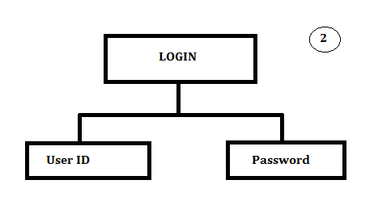

Once the Administrators logged in they can see form for Student Details where they can Insert, Delete, Update and Clear the Student Records. They also have the option to go to First Record, Last Record, Next Record and Previous Record.

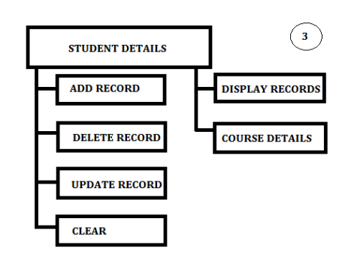

Next, there is an option to maintain the Course Details, when you click a Specific button. We will discuss that later.

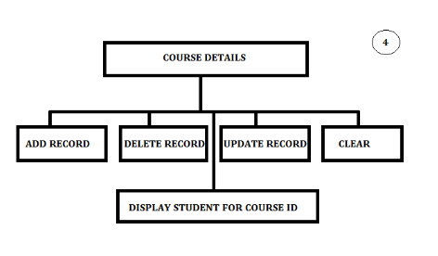

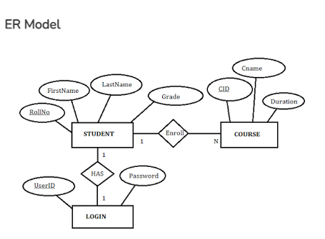

**CODE**

import javax.swing.*; import java.awt.event.*; import java.awt.*; import java.io.File;

import javax.swing.filechooser.FileNameExtensionFilter; import java.util.*;

class LoginFrame extends JFrame

{

JButton b1 , b2; JLabel l1;

public LoginFrame()

{

super("LOGIN PAGE");

setSize(800 , 550); setResizable(true); setLocation(200 , 50); setLayout(null);

setDefaultCloseOperation(EXIT_ON_CLOSE);

b1 = new JButton(" START YOUR REGISTRATION FORM ");

b1.setBounds(250, 400 , 300 , 50);

add(b1);

l1 = new JLabel(); l1.setBounds(200, 30 , 700 , 300); l1.setIcon(new ImageIcon("9.jpg")); add(l1);

b1.addActionListener( new ActionListener()

{

public void actionPerformed(ActionEvent e)

{

}

});

LoginFrame.this.setVisible(false); new Frame2();

setVisible(true);

}

}

class Frame2 extends JFrame

{

JLabel l1,l2; JTextField t1,t2; JButton b1; public Frame2()

{

super("LOGIN PAGE");

setSize(500 , 500); setResizable(true); setLocation(200 , 50); setLayout(null);

setDefaultCloseOperation(EXIT_ON_CLOSE);

l1 = new JLabel("USERNAME: "); l1.setBounds(80,150,150,30); add(l1);

t1 = new JTextField(); t1.setBounds(230,150,200,30); add(t1);

l2 = new JLabel(" PASSWORD: "); l2.setBounds(80 , 190 , 150 , 30); add(l2);

t2 = new JTextField(); t2.setBounds(230 , 190 , 200 , 30); add(t2);

b1 = new JButton("LOGIN"); b1.setBounds(150 , 330 , 150, 30); add(b1);

b1.addActionListener(new ActionListener()

{

public void actionPerformed(ActionEvent ae)

{

if(t1.getText().equals(""))

{

JOptionPane.showMessageDialog(Frame2.this,"Please Enter USERNAME","ALERT",JOptionPane.ERROR_MESSAGE);

return;

}

else if(t2.getText().equals(""))

{

JOptionPane.showMessageDialog(Frame2.this,"Please Enter PASSWORD","ALERT",JOptionPane.ERROR_MESSAGE);

return;

}

else if(t1.getText().equals("admin") && t2.getText().equals("admin1234"))

{

Frame2.this.setVisible(false); new Frame3();

}

else

{

JOptionPane.showMessageDialog(Frame2.this,"USERID OR WORNG IS WORNG","ALERT",JOptionPane.ERROR_MESSAGE);

return;

}

}

});

setVisible(true);

}

}

class Frame3 extends JFrame

{

JLabel l1,l2,l3,l4,l5,l6,l7; JTextField t1,t2,t3,t4,t5; JButton b1, b2, b3; String data;

public Frame3()

{

super("STUDENT DETAILS");

setSize(500 , 500); setResizable(true); setLocation(200 , 50); setLayout(null);

setDefaultCloseOperation(EXIT_ON_CLOSE); l1 = new JLabel("ENTER FIRST NAME ");

l1.setBounds(80 , 50 , 150 , 30); add(l1);

t1 = new JTextField(); t1.setBounds(230 , 50 , 200 , 30); add(t1);

l2 = new JLabel("ENTER LAST NAME ");

l2.setBounds(80 , 100 , 150 , 30); add(l2);

t2 = new JTextField(); t2.setBounds(230 , 100 , 200 , 30); add(t2);

l3 = new JLabel("SELECT GENDER ");

l3.setBounds(80,150,150,30); add(l3);

t5 = new JTextField(); t5.setBounds(230,150,200,30); add(t5);

l4 = new JLabel(" ENTER BRANCH ");

l4.setBounds(80 , 190 , 150 , 30); add(l4);

t3 = new JTextField(); t3.setBounds(230 , 190 , 200 , 30); add(t3);

l5 = new JLabel("ENTER ADDRESS ");

l5.setBounds(80 , 230 , 150 , 30); add(l5);

t4 = new JTextField(); t4.setBounds(230 , 230 , 200 , 30); add(t4);

b2 = new JButton("SUBMIT DETAILS");

b2.setBounds(150 , 330 , 150, 30); add(b2);

b2.addActionListener(new ActionListener()

{

public void actionPerformed(ActionEvent ae)

{

if(t1.getText().equals(""))

{

JOptionPane.showMessageDialog(Frame3.this,"Please Enter FIRST NAME","ALERT",JOptionPane.PLAIN_MESSAGE);

return;

}

else if(t2.getText().equals(""))

{

JOptionPane.showMessageDialog(Frame3.this,"Please Enter LAST NAME","ALERT",JOptionPane.PLAIN_MESSAGE);

}

else if(t5.getText().equals(""))

{

JOptionPane.showMessageDialog(Frame3.this,"Please Enter GENDER","ALERT",JOptionPane.PLAIN_MESSAGE);

}

else if(t3.getText().equals(""))

{

JOptionPane.showMessageDialog(Frame3.this,"Please Enter DEPARTMENT","ALERT",JOptionPane.PLAIN_MESSAG E);

}

else if(t4.getText().equals(""))

{

JOptionPane.showMessageDialog(Frame3.this,"Please Enter ADDRESS","ALERT",JOptionPane.PLAIN_MESSAGE);

}

else

{

String s1 = "STUDENT NAME :

"+t1.getText().trim()+" "+t2.getText().trim()+"\n";

String s2 = "ADDRESS : "+t4.getText().trim(); String s3 = "BRANCH : "+t3.getText().trim(); String s4 = "GENDER : "+t5.getText().trim();

Frame3.this.setVisible(false); new Frame4(s1,s2,s3,s4);

}

}

});

setVisible(true);

}

}

class Frame4 extends JFrame

{

JLabel l1,l2,l3,l4,l5,l6,l7; JTextField t1,t2,t3,t4,t5; JButton b1, b2, b3; String data;

public Frame4(String s1, String s2, String s3, String s4)

{

super("STUDENT DETAILS");

setSize(500 , 500); setResizable(true); setLocation(200 , 50); setLayout(null);

final String s5= s1; final String s6= s2; final String s7= s3; final String s8= s4;

setDefaultCloseOperation(EXIT_ON_CLOSE);

l1 = new JLabel("ENTER SSC PERCENTAGE: ");

l1.setBounds(40 , 50 , 150 , 30); add(l1);

t1 = new JTextField(); t1.setBounds(270 , 50 , 200 , 30); add(t1);

l2 = new JLabel("ENTER HSC PERCENTGE: ");

l2.setBounds(40 , 100 , 150 , 30); add(l2);

t2 = new JTextField(); t2.setBounds(270 , 100 , 200 , 30); add(t2);

l3 = new JLabel("ENTER YOUR AVERAGE POINTER: ");

l3.setBounds(40,150,200,30); add(l3);

t5 = new JTextField(); t5.setBounds(270,150,200,30); add(t5);

");

l4 = new JLabel(" HAVE ENROLED FOR NTPEL:

l4.setBounds(40 , 190 , 200 , 30); add(l4);

t3 = new JTextField(); t3.setBounds(270 , 190 , 200 , 30); add(t3);

l5 = new JLabel("HAVE YOU JIONED ANY COMMITIE: ");

l5.setBounds(40 , 230 , 200 , 30); add(l5);

t4 = new JTextField(); t4.setBounds(270 , 230 , 200 , 30);

add(t4);

b2 = new JButton("CONTINUE"); b2.setBounds(150 , 330 , 150, 30); add(b2);

b2.addActionListener(new ActionListener()

{

public void actionPerformed(ActionEvent ae)

{

if(t1.getText().equals(""))

{

JOptionPane.showMessageDialog(Frame4.this,"Please Enter SSC PERCENTAGE","ALERT",JOptionPane.PLAIN_MESSAGE

);

return;

}

else if(t2.getText().equals(""))

{

JOptionPane.showMessageDialog(Frame4.this,"Please Enter HSC MARKS","ALERT",JOptionPane.PLAIN_MESSAGE);

}

else if(t5.getText().equals(""))

{

JOptionPane.showMessageDialog(Frame4.this,"Please Enter AVERAGE POINTER","ALERT",JOptionPane.PLAIN_MESSAGE);

}

else if(t3.getText().equals(""))

{

JOptionPane.showMessageDialog(Frame4.this,"Please Enter COMMITTE NAME","ALERT",JOptionPane.PLAIN_MESSAGE);

}

else if(t4.getText().equals(""))

{

JOptionPane.showMessageDialog(Frame4.this,"Please Enter NTEPL COURSE","ALERT",JOptionPane.PLAIN_MESSAGE);

}

else

{

String s9 = "SSC PERCENTAGE

"+t1.getText().trim();

String s10 = "HSC PERCENTAGE

"+t2.getText().trim()+"\n";

String s11 = " COMMITTE: "+t4.getText().trim(); String s12 = "NTEPL COURSE NAME :

"+t3.getText().trim();

String s13 = "AVERAGE POINTER :

"+t5.getText().trim();

Frame4.this.setVisible(false);

new Frame5(s5,s6,s7,s8,s9,s10,s11,s12,s13);

}

}

});

setVisible(true);

}

}

class Frame5 extends JFrame

{

JLabel l1 , l2, l3, l4, l5,l6,l7,l8,l9,l10; JButton b1, b2;

public Frame5(String s1, String s3, String s2, String s4, String s5, String s6, String s7, String s8,String s9 )

{

super("STUDENT");

setSize(1000 , 900); setResizable(true); setLocation(200 , 70); setLayout(null);

setDefaultCloseOperation(EXIT_ON_CLOSE);

l1 = new JLabel(s1); l1.setBounds(50 , 20 , 300 , 30); add(l1);

l4 = new JLabel(s4); l4.setBounds(50 , 70 , 300 , 30); add(l4);

l2 = new JLabel(s2); l2.setBounds(50 , 120 , 300 , 30); add(l2);

l3 = new JLabel(s3); l3.setBounds(50 , 170 , 300 , 30); add(l3);

l5 = new JLabel(s5); l5.setBounds(50 , 220 , 300 , 30);

add(l5);

l6 = new JLabel(s6); l6.setBounds(50 , 270 , 300 , 30); add(l6);

l7 = new JLabel(s7); l7.setBounds(50 , 320 , 300 , 30); add(l7);

l8 = new JLabel(s8); l8.setBounds(50 , 370 , 300 , 30); add(l8);

l9 = new JLabel(s9); l9.setBounds(50 , 420 , 300 , 30); add(l9);

b1 = new JButton(" MAKE A NEW ENTERY ");

b1.setBounds(250, 400 , 150 , 50); add(b1);

b2 = new JButton(" EXIT "); b2.setBounds(400, 400 , 150 , 50); add(b2);

b1.addActionListener( new ActionListener()

{

public void actionPerformed(ActionEvent e)

{

setVisible(false); new Frame3();

}

});

b2.addActionListener( new ActionListener()

{

public void actionPerformed(ActionEvent e)

{

System.exit(0);

}

});

setVisible(true);

}

}

public class Studentdetails

{

public static void main(String [] args)

{

new LoginFrame();

}

}



Welcome page

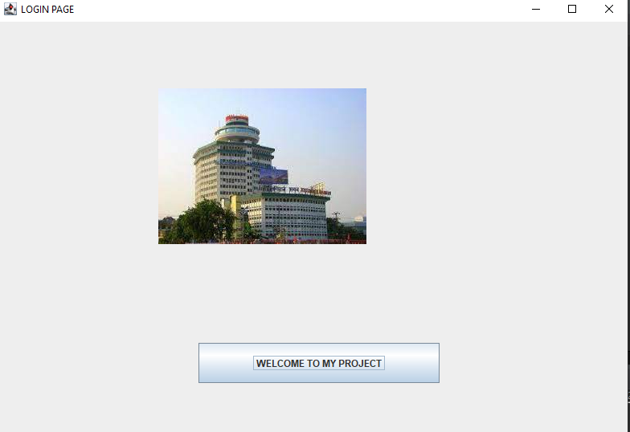



Login Frame

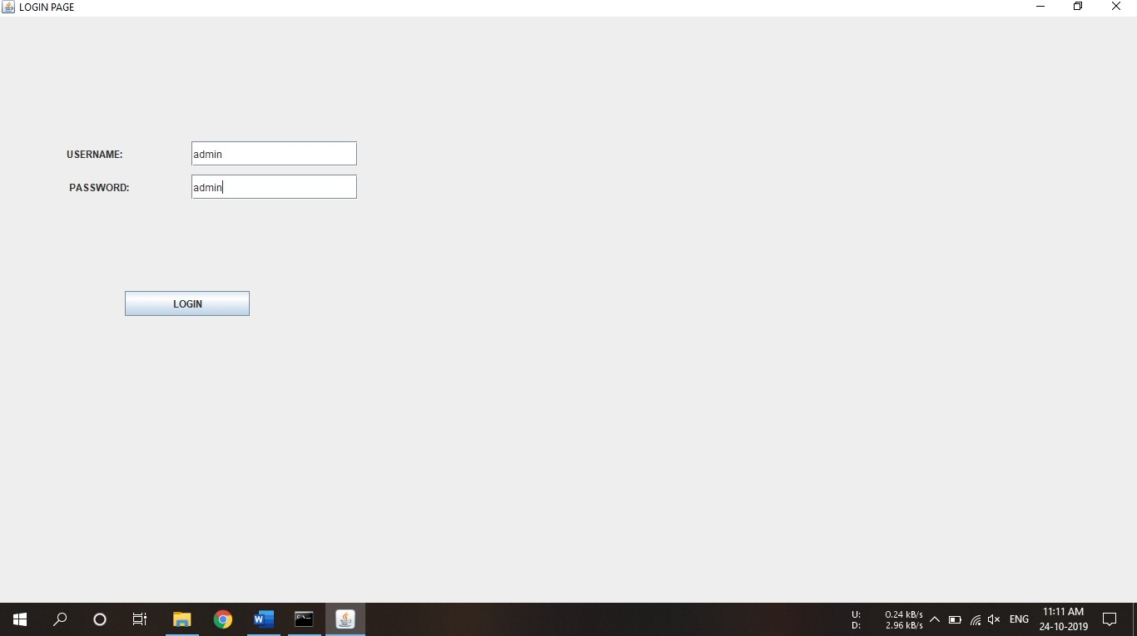



Credential verification

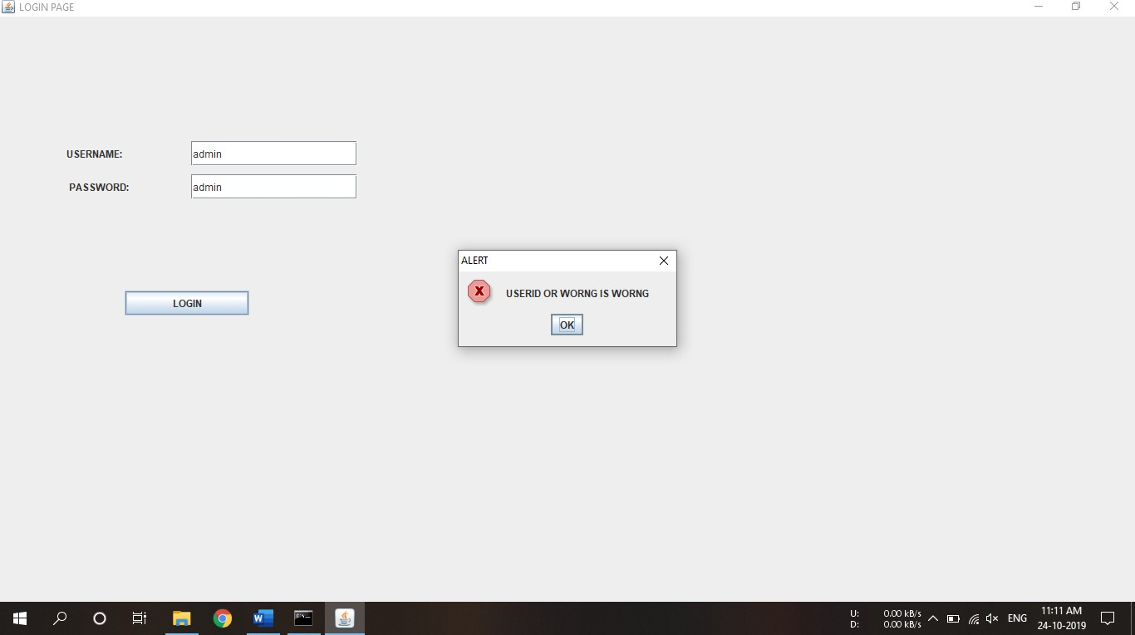



User input

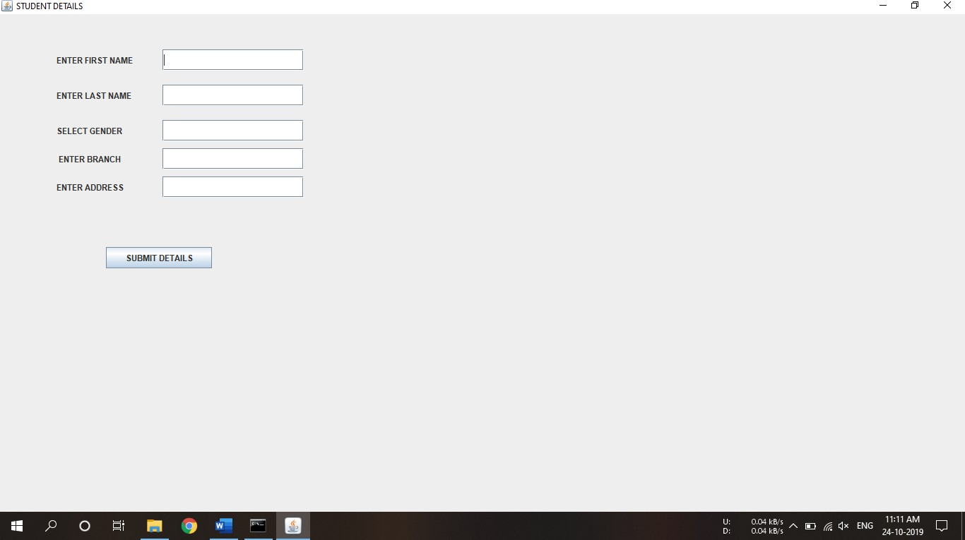

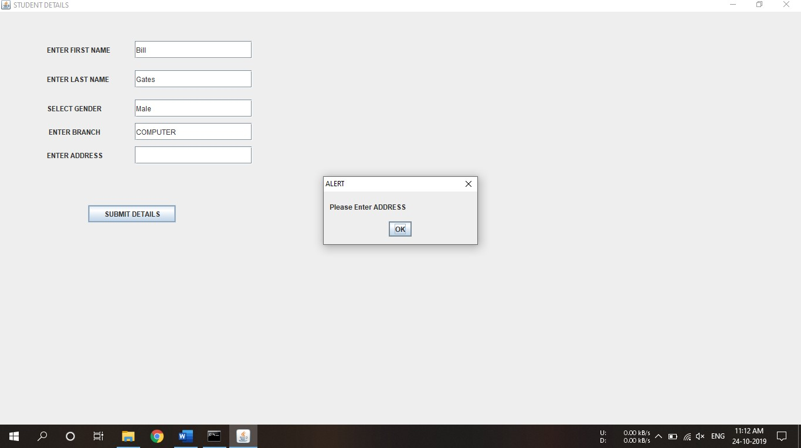

User input verification



Additional inputs

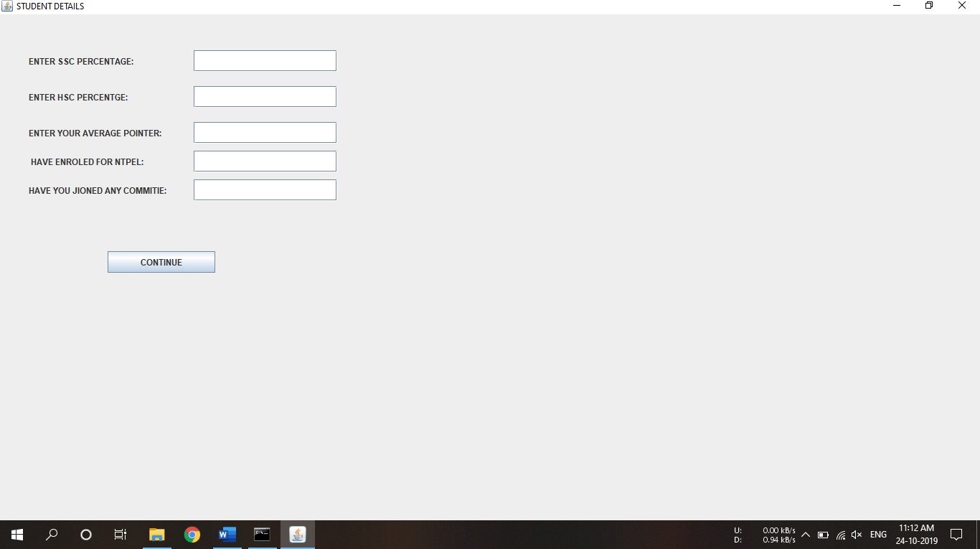

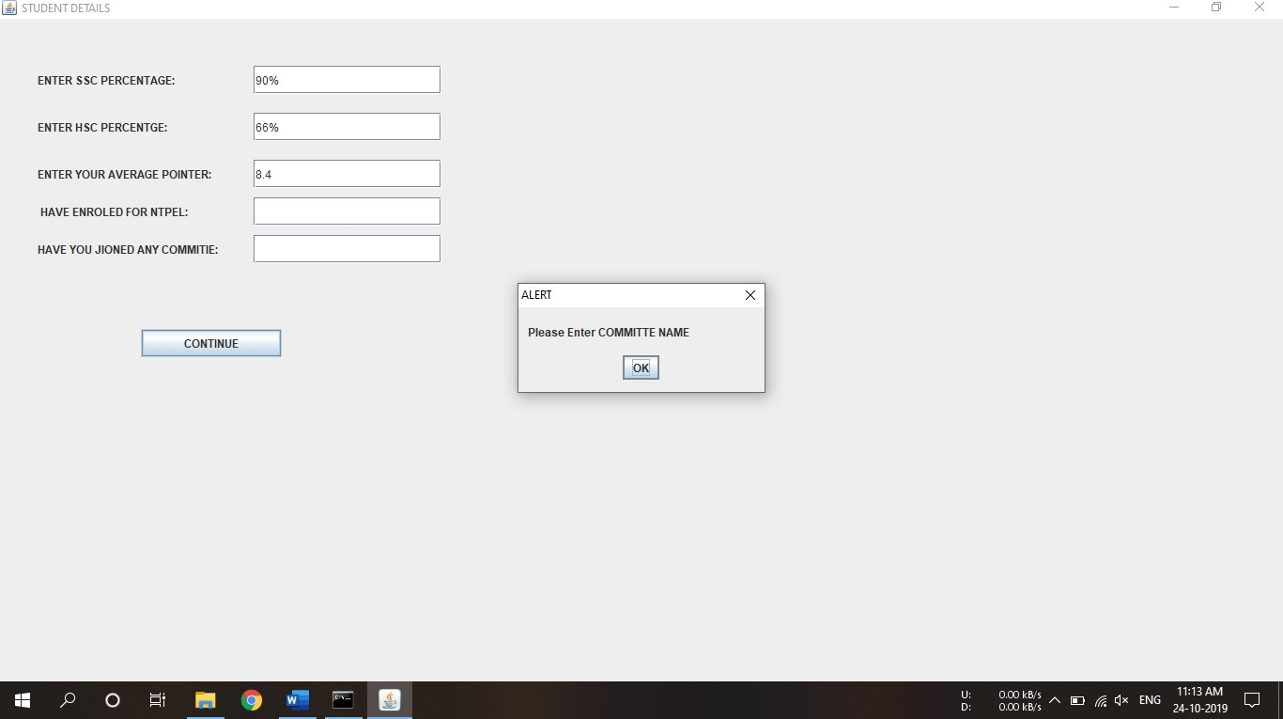

User input verfication

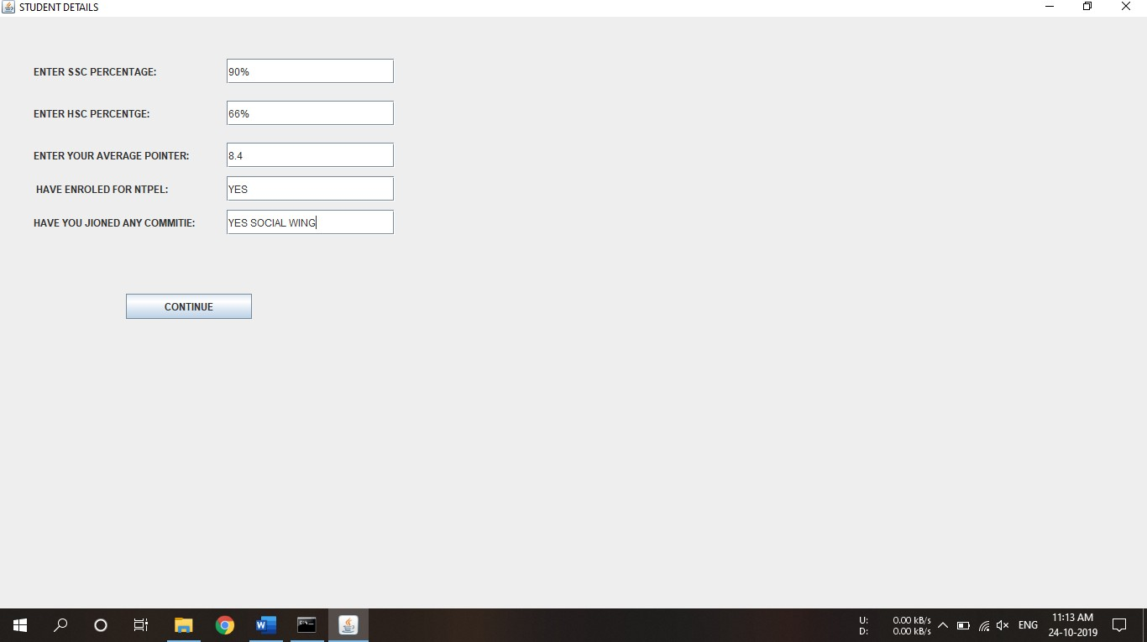



Displaying user details

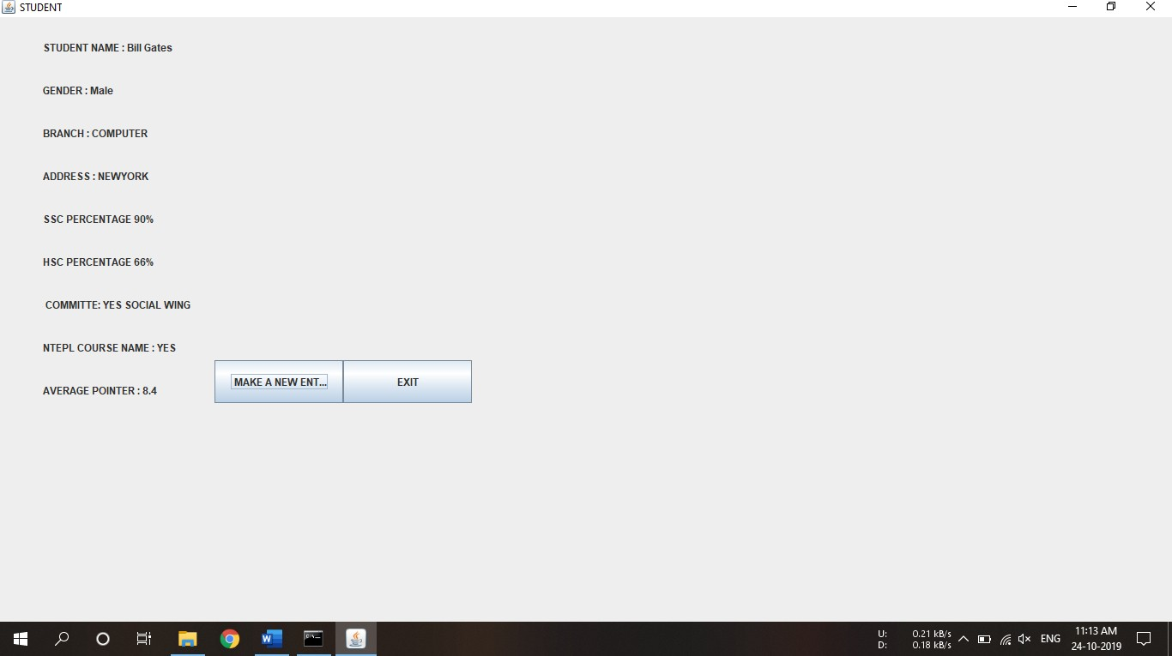



Making new entry

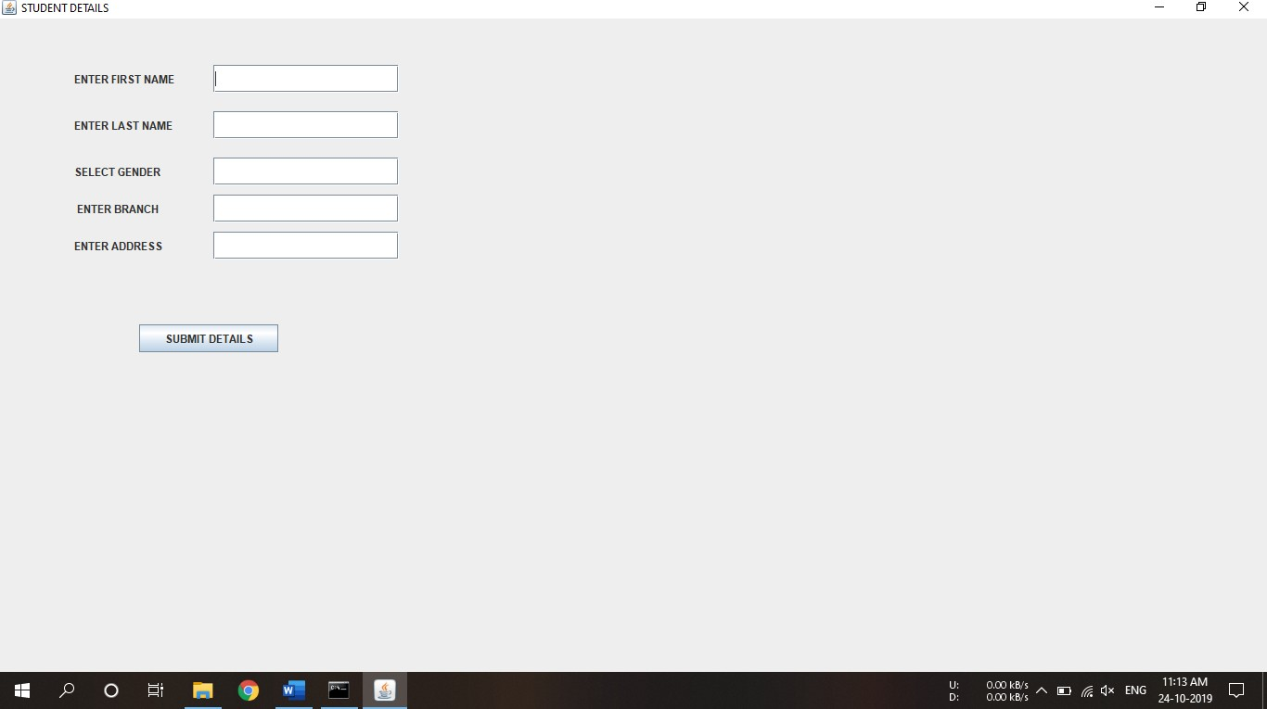

**TESTING APPROACH**

Computer s/w has become more complex. The need for specialized testing approaches has also grown. The "white box" and "block box testing methods are applicable across as environments.

GUI present integrity challenges for software engineers. Because of reusable components provided, the creation of the user interface has become less time consuming and more process. But at the same time the completely of GUEs has grown, leading to more difficulty is the design and execution of test crises. Finites step modeling graphs man is used to drive a series of test that address specific data and programs objects that are relevant to the GUI. Due to the large no of permutation associated with GUI operations testing should be approached using automated fools.

**Verification and validation:-**

Verification refers to the sit of activity that insures That software correctly implements a specific function. Validation refresh to a different set of activities that insure that the software that has built that is traceable customer requirements.

In other words validation provides final assurance that software meets all functional, behavior and performance requires.

* **Verification:-** Are we building the product right
* **Validation:**- Are we building the right product

verification and validation encompasses a wide array of SOA (software quality assurance) activities that include formal technical review, quality and configuration audits, performance monitoring, simulation, fusibility study, documentation review, development testing, qualification testing and installation testing.

**Software testing strategy:-**

A strategy for software testing may also be viewed in the context of the spiral.

Unit testing is begins at the vortex of the spiral and concentration on each unit (component) of the software as implemented in source code Testing programs by moving outward along the spiral to integrated testing, where the focus is on design and construction of the software architecture. Taking another term out word on the

spiral be in countered validation testing, where requirements established as part of software requirement analysis are validated. against the software that has been constructed. Finally we arrive other at system testing where the s/w we special out along stream lines that we spiral the scope of testing with each turned .

**Unit testing:-**

Unit testing focus verification afford on the smallest unit of the software design the software component module. Using component level design description as a guide, important control paths are tested to uncover within the boundary of the module. The unite test is white box printed. The test that occurs as parts of unit tests is lustrated schematically.

The module interface is tested to insure that information property follows into and out of the program unit under test. The local data structure is examined to insure that data stored temporarily maintains its integrity during all steps in an algorithms execution. Boundary condition are tested to insure that the module operates properly at boundaries established to limit or restrict processing. All independent paths through the control structure are executed at Mast once. And finally all error handling paths are tested.

**Integration testing:-**

Integration testing is a systematic technique for contracting the program structure while at the same time conduction tests to uncover error associated with interfacing . A number of different incremental integration strategies are:-

Components are combining to form clusters 0,1,2,&3.Each of the cluster is tested using a driver (shown (--) block).Components in cluster 1 & 2 subordinate to "Ma". Similarly driver "03" for cluster 3 is removed prior to integration with module "Mb". Both "Ma" and "Mb" will ultimately bee integrated with component "Mc" and forth.

Integration moves upward.

**Validation testing –**

Software validation is achieved through a series of "black box tests that demonstrates conformity with requirements. Each validation test case has been conducted, one of two possible conditions exists:-

1. The functions or performance characteristics conform to specification and are accepted.

2. A deviation from specification is uncovered and a deficiency list is created, Deviation or error discovered at this stage in a project can recovery be corrected prior to schedule delivery.

There are two type of validation testing are:-

a. Alpha testing

D. Beta testing

A Alpha testing:-

The alpha test is conducted at the developer's site by a customer the software is used in natural setting with the developer "locking over and shoulder of the user and recording error and using problems. Alpha test are conducted in a control environment.

B. Beta testing:-

Beta testing is conducted at one or more costumer site by the and user of the software.

Unlike alpha testing, the developer is generally not present. There fore the beta test is a "live" application of the software in an environment that cam not be controlled by the developer. The customer records all.

Problems that are encountered during beta testing and reports these to the developer at regular intervals. As a result of problems reported during beta tests, software engineers make modifications and than prepare for relation of the software product to the enter customer based.

* **System testing :-**

System testing is actually a series of different tests who's primary purpose is to fully exercise the computer based system. Although each test has a different purpose, all work of verify that system have been property integrated and perform allocated functions.

* **Recovery testing:-**

Recovery testing is a system test that force the software to fail in a variety of ways and verifies that recovery is property perform. If recovery is automatic (perform by the systems itself) reutilization, check pointing mechanism, data recovery and restart are evaluated for correctness. It recovery requires human intervention, the mean- time-to-repair (HTTR) is evaluated to determine whether it is within acceptable limits

* **Security Testing –**

Security testing attempts to verify that protection mechanism but into a system will infect, protect if form improper penetration. During security testing the tester plays the role of the individual who desire to penetrate the system. The role of the system designer is to make penetration cost more than the value of the information that will be obtained.

**Debugging Process: –**

Debugging ProcessDebugging occurs as a consequence of successful testing.That is, when a test case uncovers and error, debugging is the process that results in the removal of the error.

Integration Testing

Unit Testing

Debugging

The Debugging process will always have one of two outcome:-

1. The cause will be found and corrected.
2. The cause will not be found.

The person performing debugging may suspect a cause, design a test case to help validate the suspicion, and work toward error correction in an iterative fashion.

**Software maintenance :-**

Software maintenance is of course for more than “fixing mistakes”. We may define maintains by describing four a activates that are under ken after a program is released for use Four different maintained activates are:-

* **Corrective maintain:-**

Even with the best quality assurance activates, it is likely that the customer will uncover defects in the software. Corrective main tense changes the software to correct defects.

* **Adaptive Maintains: -**

Overtime, the original environment (CPU, OS, business rules, external product characteristics) for which the software was developed in likely to change. Adaptive maintains result in modification to the software to accommodate change to its external environment.

* **Perfective maintains or enhancement maintence :-**

As software is used, the customer/user will recognize additional function that will provide benefit. Perfective maintence extends the software beyond its original function requirement.

**4.Preventive Maintence / Roengineering : -**

Computers software deteriorates due to change, and because of this, preventive maintence , often called software engineering, and must be conducted to enable the software to serve the needs of its end users. In essence, preventive maintains makes change to computer programs so that they can be more easily corrected, adapted and enhanced

**5.Installation testing :-**

Implementation means to take into practice. A crucial phase in the system line cycle is the successful implementation of the new system design. Implementation includes all those activities that takes place to convert or automated system.

The software of student profile management System completely new system i.e. the existing system is manual.

**The main aspects of implementation are as follows:-**

* Training personnel.
* Conversion procedure.
* •Demonstration.

For the proposed profile management System will be beneficial. Under this approach, users continue to operate the old system in the usual manner but they also start using the new system. This method is safest one because it ensures that in case of Any problem in using the new system, the organization can still fall back to the old system without loss of time and money.

**Modifications and Improvements:-**

The title of employee training system can make the project during different types of modification when compile the program then different types come of error read and a correct debug and then compile the program. Project during compile and run to again then when correct the program so, I check the fill data and different types of validation creating during the project.

**VALIDATION CHECKS**

In this project system checks the entered data valid or not. If data is valid then system accepts the data and is involved then system show error message and give prompt for re-enter the correct data.

The validation check when the saving the data or pressing the <enter> key.

**TOOLS/PLATFORM**

Enviromental Characteristics:

**Minimum Hardware required for the Proposed System.**

* Pentium 600 MHz. or higher microprocessor.
* VGA 640 x 480 or high resolution screen supported by microsoft windows..
* 500 MB RAM for window XP,
* 100GB higher capacity hard disk.

**Software Used:-**

* **Microsoft windows xp second edition operation system.**
* **Java-language.**

**Limitation of Project**

Although our sample of practices reflected the practices participating in the randomized controlled trial, within practices we interviewed staffs of the company who were low users of computers. The people in the feedback group were self selecting and likely to include disproportionately more of those with strong reactions to the system. The voice of the disappointed enthusiast comes across strongly, and we know less about the views of those people who chose not to try the system. However, although the level of criticism of the system varied between staff at different levels in the company, the nature of the criticisms, in terms of where the problems lay with the system, was remarkably consistent.

**Future Scope of the project**

This project has been developed keeping in view the current requirements of the Organization. This project eventually automates all A to Z training related activities, requirements and master the maintenance of the system Generates the important report like as on range of dates. Reduces processing time .

* Increases efficiency of system
* Emphasis on accuracy of data
* Assures security and validity.
* Provision for enhancement without distributing the developed modules.
* Object -Oriented design
* GUI based full mouse and keyboard supported forms
* Fully automated, Employee training system got the option of entry , amendments report generation as well as printing.



Thus, using a GUI based java application we have successfully created a application with a welcome page, login verification page ,which takes various student details as input, verifies them and displays it in the end.

A major advantage of GUI is that it makes computer operation more intuitive and thus easier to learn and use.

Icons are more user friendly than long command lines. GUIs provide the user with immediate,visual feedback about the effect of each action.

BIBLIOGRAPHY

#### BOOKS REFERED

* Introduction To Programming with java
* Head First java

#### WEB LINK

* http;//[www.W3school.com](http://www.W3school.com/)
* http;//[www.alvbcode.co](http://www.alvbcode.co/)
* https://www.geeksforgeeks.org